Office of Drug Control
  - Compliance & Enforcement Framework
  - 2025 – 2028
Version 1.0, December 2025



Ownership of intellectual property rights

© Commonwealth of Australia 2025
This work is copyright. You may download, display, print and reproduce the whole or part of this work in unaltered form for your own personal use or, if you are part of an organisation, for internal use within your organisation, but only if you or your organisation do not use the reproduction for any commercial purpose and retain this copyright notice and all disclaimer notices as part of that reproduction. Apart from rights to use as permitted under the Copyright Act 1968 or allowed by this copyright notice, all other rights are reserved, and you are not allowed to reproduce the whole or any part of this work in any way (electronic or otherwise) without first being given specific written permission from the Commonwealth to do so. Requests and inquiries concerning reproduction and rights are to be sent to the
ODC Copyright Officer, Office of Drug Control, PO Box 100, Woden ACT 2606 or emailed to ODC.compliance@health.gov.au
The Australian Government acting through the Office of Drug Control in the Department of Health, Disability and Ageing has exercised due care and skill in the preparation and compilation of the information and data in this publication. Notwithstanding, the department, its employees and advisers disclaim all liability, including liability for negligence, for any loss, damage, injury, expense or cost incurred by any person as a result of accessing, using or relying upon any of the information or data in this publication to the maximum extent permitted by law.

Version control
Updates to this document will occur automatically on the Office of Drug Control website and the revision table below will list the amendments as they are approved.
Date | Version | Amendments
December 2025 | 1.0 | First publication

Contents

1. Introduction 4
Enhance stakeholder engagement and collaboration 5
Promote compliance with regulatory requirements 5
2. Legislative requirements 5
3. Risk-based approach to compliance 6
4. Compliance monitoring 8
5. Intelligence collection and analysis 8
Inspection trends 9
Public media alerts 9
Notifications 9
Tip-Offs and complaints 9
Prioritisation 10
6. Stakeholder engagement and education 10
Monitoring and education campaigns 10
7. Compliance inspections 10
Virtual inspections 11
On-site announced inspections 11
On-site unannounced inspections 11
Cost recovery 11
8. Investigations 11
9. Enforcement 11
Compliance and enforcement tools 12
10. Administrative law principles 14

Compliance and enforcement framework 2025-2028

1. Introduction
The Office of Drug Control (ODC), as part of the Department of Health, Disability and Ageing, regulates the import, export, cultivation, production and manufacture of controlled drugs as part of Australia’s obligations under the International Drug Conventions:
- Single Convention of Narcotic Drugs 1961 (as amended by the 1972 protocol)
- Convention on Psychotropic Substances 1971
- United Nations Convention against illicit traffic in Narcotic Drugs and Psychotropic Substances of 1988.
The purpose of the drug conventions is to provide an international framework that recognises the medicinal and scientific value of narcotic and psychotropic drugs and ensure that these drugs are available for legitimate purposes.
Our core regulatory functions are undertaken by the Narcotics Control Section, the Medicinal Cannabis Section, and the Monitoring and Compliance Section.
- Medicinal Cannabis Section – assesses licence and permit applications for the cultivation, production, and manufacture of medicinal cannabis under the Narcotic Drugs Act 1967 (Narcotic Drugs Act). This section also performs various administrative functions that help the ODC meet its regulatory obligations, and administers the medicinal cannabis cost recovery framework.
- Narcotics Control Section – regulates the manufacture of narcotic drugs and the import and export of controlled drugs in Australia through licensing and permits. It ensures compliance with international drug treaties and collaborates with bodies like the International Narcotics Control Board (INCB) and domestic law enforcement. The section collects and reports data on controlled substances, supports industry and government agencies with guidance and operational coordination, and administers key legislation, playing a vital role in maintaining regulatory oversight and supporting secure, lawful handling of narcotics and related substances.
- Monitoring and Compliance Section – ensures the effective compliance of licence and permit holders in meeting their obligations under relevant legislation, including the Narcotic Drugs Act. The section employs a range of legislative tools and engagement practices to ensure regulated persons comply with their legislative obligations and takes appropriate and proportionate action when required. The section works with international and domestic partners, including engaging with Commonwealth, state and territory government agencies and law enforcement at all levels, to exchange information and manage regulatory compliance risks including resolving cross-jurisdictional issues.
This Compliance Framework outlines how the ODC will regulate the cultivation, production, manufacture, import, export, and supply of controlled substances in Australia over the period 2025–2028. It ensures our regulatory approach is proportionate, intelligence-led, transparent, and capable of responding to emerging risks and obligations.

Enhance stakeholder engagement and collaboration
The ODC will be open and responsive to feedback about our processes and regulatory decisions. The ODC engages regularly with stakeholders and offers a range of mechanisms for the public and regulated persons to engage with us and provide feedback, including:
- undertaking compliance campaigns aligned to our Compliance Enforcement Strategy 2025-2028. The campaigns will be designed to inform and educate stakeholders on regulatory compliance matters with the aim of encouraging best practice procedures.
- continuing to build stronger stakeholder relationships, including looking for opportunities to cooperate with law enforcement, state and territory regulators and other agencies.
- collaborating with international partners, including INCB.
- working with industry peak bodies and licence and permit holders to share trends and identified risks.

Promote compliance with regulatory requirements
The ODC takes a risk-based approach to regulation and compliance, allocating resources to areas with higher risk or concern to strengthen community confidence in the regulation of controlled drugs. Data collected through monitoring activities is used to identify non-compliance trends and guide compliance priorities and educational activities. In doing this, risks are managed in a proportionate manner.
Compliance with regulatory requirements will be promoted by:
- implementing the ODC Compliance and Enforcement Framework 2025-2028
- meeting our compliance goals specified in the Portfolio Budget Statement for narcotic drugs licence and permit holders and ensure that an outcome report is issued within 2 months of each inspection.
The Framework is consistent with, and provides further detail on key aspects of, the ODC publication Risk management approach to the cultivation, production and manufacture of medicinal cannabis, available at www.odc.gov.au.

2. Legislative requirements
Regulated persons are responsible for understanding their obligations for import, export, cultivation, production and the manufacture of narcotic drugs.
The Narcotic Drugs Act 1967 gives effect to Australia’s obligations under the Single Convention on Narcotic Drugs of 1961 (as amended by the 1972 Protocol) (Single Convention) and provides a regulatory framework for:
- the cultivation of cannabis plants, the production of cannabis and cannabis resin, the manufacture of cannabis drugs, and related activities
- the manufacture of other narcotic drugs as covered by the Single Convention.
The Customs Act 1901 (Customs Act) is the legislative authority that sets out the customs requirements for the importation and exportation of goods to and from Australia. The Customs (Prohibited Imports) Regulations 1956 and Customs (Prohibited Exports) Regulations 1958 further outline requirements and restrictions.
Additional legislative requirements also apply as set out in:
- Narcotic Drugs Regulation 2016 (Narcotic Drugs Regulation)
- An instrument made under the Narcotic Drugs Act which supports the regulatory framework
- Narcotic Drugs (Licence Charges) Act 2016
- Imposes charges on licences granted under the Narcotic Drugs Act
- Regulatory Powers (Standard Provisions) Act 2014 (Regulatory Powers Act)
- Provides a standard suite of provisions for government regulatory agencies in relation to monitoring and investigation powers, and enforcement measures, whilst providing safeguards and protecting important common law privileges for regulated entities
- Criminal Code Act 1995
- Legislates the general principles of criminal responsibility under laws of the Commonwealth, irrespective of how the offence is created
- The Crimes Act 1914 (Crimes Act)
- An act relating to offences against the Commonwealth.

3. Risk-based approach to compliance
The ODC is committed to a risk-based regulatory approach that delivers strong outcomes, protects public health, and upholds compliance with international drug control conventions. By focusing on high-risk areas, the ODC aims to allocate resources efficiently and proportionately.
This approach enables the ODC to respond appropriately to the nature and severity of non-compliant behaviour by regulated entities. When assessing risks associated with a particular business, the ODC considers a range of factors to determine the most suitable regulatory response, including:
- probity of the applicant (fit and proper person requirements)
- type of narcotic
- quantities of narcotic required for cultivation, production and/or manufacture
- site security and storage
- location of the facility
- supply arrangements
- compliance history.
Key objectives of the ODC:
- regulate the import, export, cultivation, production and manufacture of controlled drugs
- ensure the lawful supply of controlled drugs for legitimate purposes
- prevent diversion and misuse of controlled drugs
- detect, deter and prevent fraud and corruption.
ODC’s Compliance and Engagement approach:
- apply a range of tools, including education, encouragement, and enforcement, based on intelligence and data-driven risk assessments
- balance effective compliance with minimising regulatory burden on stakeholders
- foster cooperation and innovation by ensuring regulation is reasonable and proportionate.
Regulated persons have a responsibility to ensure the risks associated with their proposed activities are clearly identified and that appropriate measures are implemented to mitigate those risks. The graphic below outlines the ODC’s approach to addressing compliance matters based on the level of identified risk.
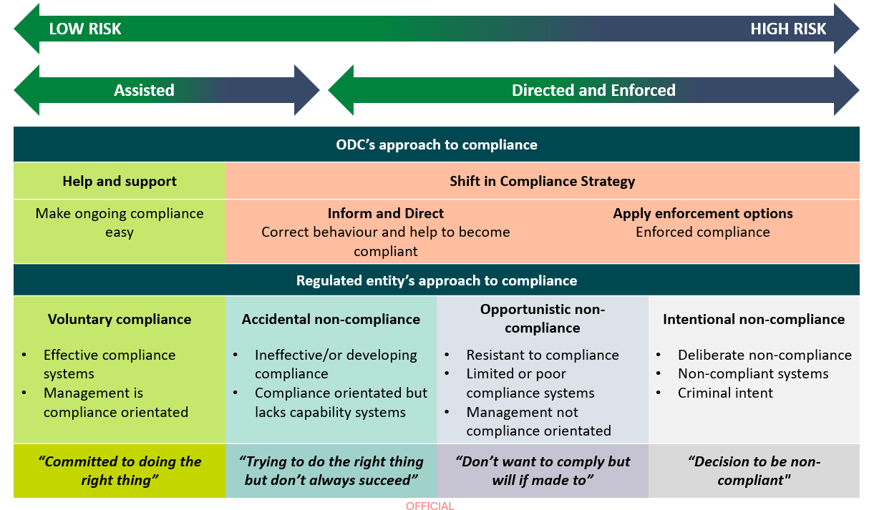
Diagram 1: ODC’s approach to compliance

The ODC will have regard to the below compliance principles when undertaking its monitoring and compliance activities:
Proportionality | The action the ODC takes is proportional to the seriousness of the non-compliance.
Consistency | The ODC ensures our decisions and actions are consistent.
Transparency | The ODC publishes general information on how to comply with the legislation.
Confidentiality | The ODC keeps your information confidential while investigating complaints. We may publish enforcement outcomes and significant decisions where in the public interest to do so.
Timeliness | The ODC investigates efficiently, ensuring that operations are not unnecessarily impeded.
Operational Efficiency | The ODC aims to minimise unnecessary regulatory burden and avoid impeding legitimate trade and operations, including timely processing of applications, permits, and variations.
Fairness | The ODC undertakes activities with integrity, professionalism, and due regard to procedural fairness.

4. Compliance monitoring
A systematic, risk-based approach to compliance activities provides the ODC with a cost-effective method to monitoring compliance. Resources are directed to higher priority and emerging regulatory risks allowing for a proactive response to changing and escalating threats. There are several ways that ODC can detect or receive information relating to non-compliance including through:
- self-reporting and notifying the ODC
- inspections or assessment activities
- tip-offs, including via anonymous sources
- referrals from industry bodies
- maintaining close relationships with law enforcement and other government agencies
- sampling of narcotics to ensure they comply with licence and permit requirements
- regular requests for information from various sources including regulated persons.
Regularly reviewing the information received assists the ODC to identify trends or behaviours that can indicate non-compliance. These insights allow us to:
- address systemic issues across the industry through targeted education and support
- focus future compliance activities on identified areas of non-compliance.
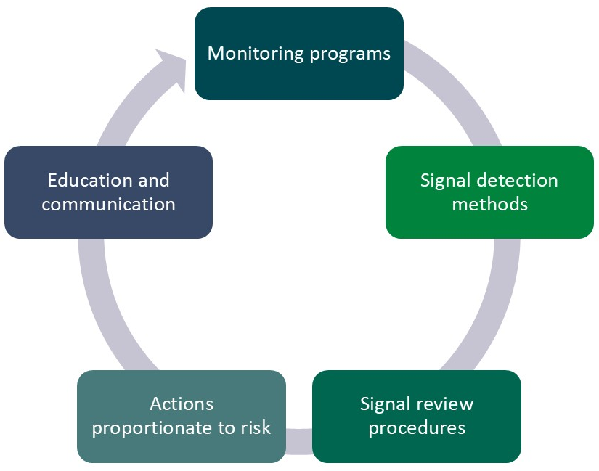
Diagram 2 – Compliance monitoring cycle

5. Intelligence collection and analysis
The ODC may collect intelligence and data from relevant Commonwealth, state or territory agencies in accordance with the Narcotic Drugs Act and other applicable legislation. This allows the ODC to have sufficient information to exercise our regulatory functions and may include cross matching the information received from the other agencies.

Inspection trends
The ODC will assess the outcomes of compliance activities to determine whether there are issues or themes relating to non-compliance. This information will inform compliance risk assessments and help target compliance and monitoring efforts. By tracking common risk areas, the ODC can build trend profiles to guide its regulatory approach and inform future compliance monitoring activities and campaigns.

Public media alerts
The ODC regularly monitors publicly available information, including media articles, particularly where potential risks are identified. The ODC also undertakes checks to verify allegations where there is an indication of a breach of the relevant legislation the ODC administers.

Notifications
It is a condition under the Narcotic Drugs Act that licence holders are required to notify certain matters to the Secretary of the Department of Health, Disability and Ageing; failure to do so is a breach of the relevant licence. Upon receipt of the notification, the ODC will triage the incident and assess the regulatory response which may include, but is not limited to:
- requiring an application to vary a licence (e.g. change of directors, security procedures or variations to site and floor plans)
- surrender of licence
- further investigations (theft or diversion)
- reviewing supply pathways.

Tip-Offs and complaints
The ODC receives tip-offs and complaints from the public, and referrals from other agencies relating to suspected non-compliance. The referral may include preliminary information to support any allegations. These can be provided to the ODC via the following channels:
- Email: odc.compliance@health.gov.au
- Office of Drug Control Tip-off form via website.
When making a tip-off or complaint, the more information provided, the better the ODC can work to protect honest businesses and the community.
If you are submitting a tip-off or complaint, useful information includes:
- the name of the individual or business
- the individual’s or business’s address
- ABN
- phone number
- website
- social media details (for example, page name and profile addresses)
- details of the behaviour you have identified
- any additional supporting material or evidence you consider relevant.
Due to privacy laws, the ODC cannot inform you of the outcome of the information you provide, nor give you updates on the progress of the matter. However, the ODC takes all information seriously and carefully considers all information received.

Prioritisation
Our regulatory actions are both proactive and responsive, including acting upon information and reports of non-compliance from several external sources.
While all instances of alleged non-compliance are recorded and considered, the ODC cannot pursue every matter that comes to our attention. We use a risk-based approach in deciding priorities, taking into consideration:
- the seriousness of any alleged or detected non-compliance
- the risk to the community of harm or injury
- the compliance history and behaviour of the regulated person
- required action prescribed under the Act
- trends indicating non-compliance across multiple licence holders or the industry generally.

6. Stakeholder engagement and education
The ODC is committed to providing clear guidance to regulated persons to promote transparency and accountability in relation to its monitoring, compliance and enforcement functions and powers. This includes explaining how the ODC exercises its regulatory powers.
To help regulated persons understand their legislative obligations, the ODC may publish resources such as fact sheets, case studies or information on our website.

Monitoring and education campaigns
The ODC carries out targeted campaigns. These campaigns may be informed by trends and issues identified throughout the regulatory cycle and aim to inform and educate industry on regulatory compliance matters with the goal of promoting best practice procedures.
Monitoring and education campaign activities may include:
- onsite or virtual inspections
- presentations and stakeholder meetings
- website publications and educational materials
- direct feedback to regulated persons, where appropriate.

7. Compliance inspections
The ODC will undertake regular and random property inspections, either onsite or virtually, to assess compliance with relevant legislation. All persons are required to notify the ODC of material changes that are relevant to ongoing compliance with the Narcotic Drugs Act and the conditions of the licence. The ODC expects industry to have systems in place to undertake internal auditing and ensure compliance with the licence conditions and legislation.
Inspections may include a review of documentation and records, permit conditions, and compliance with medicinal cannabis licensing requirements. Inspections may include the use of photographic, video and drone imagery, and sampling of material. The ODC expects regulated persons to maintain internal systems that support timely and accurate reporting of changes and variations.

Virtual inspections
Virtual inspections form an important part of the ODC compliance program and assist us to deliver a flexible way of conducting our compliance program. Notices may be issued to obtain information and documents from the regulated persons. The ODC may also seek information from other sources to verify claims and detect non-compliance. Penalties may apply where a person fails to provide the requested information.

On-site announced inspections
The ODC will undertake announced compliance inspections where the regulated persons will be notified in writing prior to the on-site visit being undertaken. These inspections are generally undertaken with the consent of the occupier of the site.

On-site unannounced inspections
The ODC may conduct unannounced monitoring inspections where authorised inspectors will attend a premises without notice. While inspections may be conducted with consent of the occupier, the Narcotic Drugs Act gives authorised inspectors the power to enter premises without consent. As with announced inspections, occupants have the right to observe unannounced compliance inspections; but must not obstruct or hinder an authorised inspector, which is an offence under the Act.

Cost recovery
The Cost Recovery Implementation Statement (CRIS) for the ODC outlines how the Department of Health, Disability and Ageing implements cost recovery for regulatory activities under the Medicinal Cannabis Scheme, as governed by the Narcotic Drugs Act. It details the Fees and charges applied to licence and permit applications, compliance inspections, and other regulatory services. The CRIS ensures transparency and accountability in how costs are calculated and recovered and includes financial forecasts and performance metrics.

8. Investigations
The ODC conducts investigations in accordance with the Australian Government Investigations Standards (AGIS), which sets out the minimum standards by which government agencies are to conduct their investigations. The ODC investigates matters by utilising a range of evidence gathering powers and methods, such as:
- using monitoring or investigation powers under the Regulatory Powers Act
- requiring production of information or documents by way of a notice
- referring matters to law enforcement.

9. Enforcement
As the regulated industry has matured, the ODC’s compliance approach is evolving from primarily assisted compliance activities to more directed and enforced compliance measures. While the ODC’s focus is shifting, the ODC remains committed to education and engagement as key components of our strategy.

Diagram 3 – ODC’s Compliance Approach
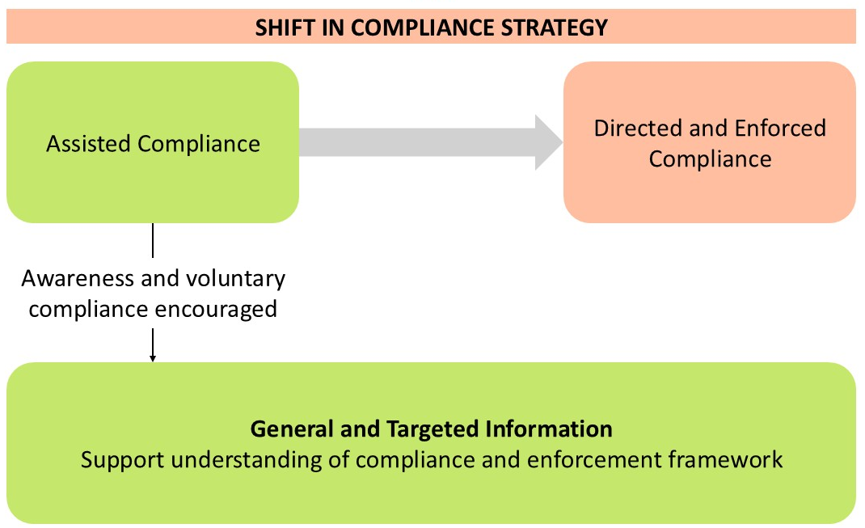
The ODC will continue to promote understanding and awareness of regulatory obligations through ongoing education and outreach efforts to key stakeholders and encouraging voluntary compliance across the industry.

Compliance and enforcement tools
The ODC employs a range of compliance and enforcement tools to address alleged non-compliance with the Narcotic Drugs Act. These tools may be used individually or in combination and are designed to encourage and promote compliance. A brief description of these tools is included below and see also Diagram 4.
Education | Activities may include onsite or virtual inspections, presentations, website updates, stakeholder meetings, and sharing information. The ODC also gives direct feedback to help regulated persons improve their practices.
Administrative activity | This includes corresponding with the applicant, including issuing warning letters. Warning letters may be issued for low compliance risks.
Infringement notices | The Narcotic Drugs Act includes criminal offences and civil penalties. If the ODC determines that the Act has been breached, it can give infringement notices instead of going to court. If the infringement notice is not paid, further action can be taken.
Directions | The ODC has the authority to issue directions concerning the security of premises, the handling and destruction of cannabis (including plants, resin, and narcotic preparations), and the manufacturing or labelling of drugs. Failure to comply with these directions constitutes a criminal offence and may also result in civil penalties.
Enforceable undertakings | The ODC may choose to negotiate an enforceable undertaking as an alternative to initiating court proceedings. This legally binding agreement requires a licence holder who has breached the law to commit to specific corrective actions. If breached, the ODC can seek enforcement orders from the Federal Court.
Injunctions | The ODC may seek an injunction from the Federal Court or Federal Circuit Court to prevent further or ongoing breaches of the Narcotic Drugs Act or Regulation, or to compel compliance where a licence holder fails or refuses to meet their legal obligations.
Suspension of licence or permit | Under the Narcotic Drugs Regulation, the ODC may suspend a licence or permit, stopping authorised activities during the suspension period. The ODC may also revoke or extend the suspension and take further enforcement action against the licence holder if necessary.
Revocation of licence or permit | The ODC may revoke a licence or permit under the Narcotic Drugs Act for various reasons, including if the licence holder or its directors commit a serious offence, are deemed unsuitable, or if associated individuals or business operations are found to be inappropriate. Additional grounds for revocation may be applied at the ODC’s discretion, based on the specific circumstances.
Civil penalty proceedings or criminal prosecutions | The Narcotic Drugs Act sets out offences that can lead to criminal penalties, including those where intent does or does not need to be proved. Serious breaches may result in criminal proceedings. The Act also contains civil penalty provisions and allows the ODC to seek court-ordered penalties for breaches of these provisions.

Diagram 4 - ODC’s Compliance and Enforcement Tools

This diagram presents the various compliance and enforcement tools at the ODC’s disposal. It is important to recognise that the diagram does not represent a fixed or sequential process. Enforcement actions are not always initiated with education, nor do they necessarily follow a set sequence. The ODC’s choice of enforcement action is determined by the particular facts of each case, including the type and seriousness of the risks involved.
The ODC will consider what enforcement action, if any, should be taken against regulated persons, ensuring that the outcomes are appropriate and proportionate in the circumstances.

10. Administrative law principles
The ODC undertakes its compliance activities with integrity, professionalism and with due regard to procedural fairness, and provides information regarding the regulated person’s rights so they can meet their obligations.
Administrative decisions, distinct from criminal prosecutions, are reviewable and must comply with the requirements of administrative law. The Narcotic Drugs Act provides a framework for the review of a range of administrative decisions, including a process for review by the Minister or, if delegated, an internal reviewer. Internal review decisions are subject to review by the Administrative Review Tribunal in accordance with the Administrative Review Tribunal Act 2024.
The Administrative Decisions (Judicial Review) Act 2017 also provides for decisions to be subject to judicial review unless prescribed as exempt.

In this document any expressions used to denote persons generally (such as “person”, “party”, “someone” etc), includes a body politic or corporation as well as an individual.

