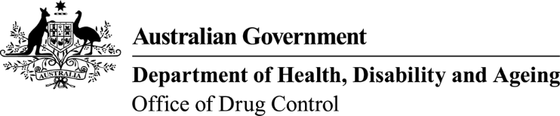 | This form, when completed, will be classified as  'For official use only'.

Application to change licensed company details
Substances controlled under Regulation 5 of the Customs (Prohibited Imports) Regulations 1956 and Regulation 10 of the Customs (Prohibited Exports) Regulations 1958.
- Licence details
Licence holder name: | Current import licence number:
Company name: | Current export licence number:
Company ABN/ACN:

- Change of company details
A copy of the updated Schedule 4 and/or Schedule 8 state/territory health licence MUST be included
Previous company name: |  | New company name:
Previous company address: |  | New company address:
Details of S4/S8 Licence: | S4/S8 Licence Number: |  | S4/S8 Licence Expiry Date:

- Declaration and consent
I declare that to the best of my knowledge all the information in this application is true, correct and complete. I am aware that giving false or misleading information is a serious offence—see Division 136 and 137 of the Criminal Code Act 1995.
I understand that it is standard practice for the Narcotics Control Section to provide any or all of the contents of this application, including personal information as defined in the Privacy Act 1988, to law enforcement agencies and regulatory agencies in the Commonwealth, States and Territories as necessary, in order to ensure laws and regulations are being complied with. I consent to all such disclosures and associated exchanges of information, including specifically personal information about me.
Signature of licence holder: | Date:
Signature of licence holder: | Position:
Signature of licence holder: | Email:
Name: | Telephone:

