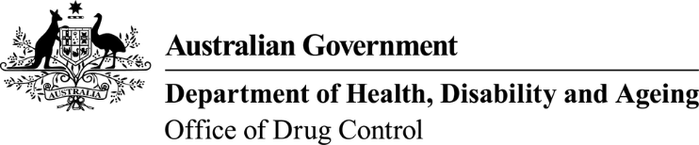 | This form, when completed, will be classified as  'For official use only'.

Application for permission to import kava
Substances controlled under Regulation 5 and 5F of the Customs (Prohibited Imports) Regulations 1956.
To assist in the completion of this form, guidance is available on the ODC website.
- Importer information |  |  |  | - Exporter information
Importer’s name: |  |  |  | Overseas exporter’s full name:
Company name:
Company address: |  |  |  | Overseas exporter’s address:
Postal address:
 |  |  |  | Export establishment ID No. (if known):
Please tick if an Express envelope has been forwarded |  |  |  | Approx. date of arrival in Australia (import):
Import establishment ID No. (if known):

Complete Section 3 For food use or Section 4 For Medical and Scientific use.
DO NOT use the same form for an application to import kava for both Food use and Medical/Scientific use. Complete separate forms.

- Kava details - Food Use Only:
Form of kava—for example, root, powder:
Pack type and size: |  |  |  |  |  |  |  | Total number of packs in shipment:
ABN: |  |  |  |  |  |  |  | GST Registered |  |  |  | Yes No
- Kava details - Medical and Scientific Use Only:
Form of kava—for example, root, powder or approved therapeutic product:
Pack type and size: |  |  |  |  |  |  |  | Concentration/strength:
Total number of packs in shipment: |  |  |  |  |  |  |  | ARTG No.:
- Declaration and Consent
I hereby apply to the Secretary, Department of Health, Disability and Ageing, for a permission to import a drug in accordance with Regulation 5F of the Customs (Prohibited Imports) Regulations 1956.
I declare that to the best of my knowledge all the information in this application is true, correct and complete. I am aware that giving false or misleading information is a serious offence (see Division 136 and 137 of the Criminal Code Act 1995).
I understand that it is standard practice for the Drug Control Section to provide any or all of the contents of this application, including personal information as defined in the Privacy Act 1988, to law enforcement agencies and regulatory agencies in the Commonwealth, States and Territories as necessary, in order to ensure laws and regulations are being complied with. I consent to all such disclosures and associated exchanges of information, including specifically personal information about me.
Signature of importer |  |  |  |  |  |  |  |  |  |  | Name:
 |  |  |  |  |  |  |  |  |  |  | Date:
Position: |  |  |  |  |  |  | Email:
Direct telephone: |  |  |  |  |  |  | Mobile:
NOTES
Monitoring of the Kava Pilot
The Department of Health, Disability and Ageing has commissioned the National Drug and Alcohol Research Centre (NDARC) and Ninti One Limited, to monitor and evaluate the kava pilot in Australia. Please note that NDARC may invite you to participate in the evaluation during the pilot period. Participation is optional.
PHAMA Plus
To understand the socio-economic impact of Australia’s commercial kava pilot on kava growers, processors, exporters and government agencies in the participating Pacific Island Countries, the Pacific Horticultural Agricultural Market Access program (PHAMA Plus) requests the support of stakeholders participating in the pilot to share information on the kava trade between the Pacific Islands and Australia:
PHAMA Plus contact: info@phamaplus.com.au

