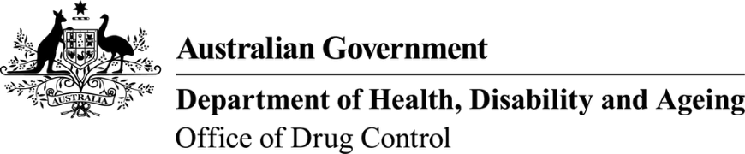 | This form, when completed, will be classified as  'For official use only'.

Application for permission to import substances under Regulation 5G and 5H of the Customs (Prohibited Imports) Regulations 1956
Substances controlled under Regulation 5G/5H of the Customs (Prohibited Imports) Regulations 1956.
To assist in the completion of this form, guidance is available on the ODC website
Raw material OR Finished goods
- Importer information
Importer’s name: |  |  |  |  | Importer’s state/territory licence number:
Company name: |  |  |  |  | Importer’s state/territory licence number:
Company address:
Postal address:
Please tick if an express envelope has been provided
2. Exporter information
Overseas exporter’s full name:
Overseas exporter’s address:

3. Substance details
Substance name:  (e.g. Testosterone)  (include CAS number, if known): |  |  |  |  | Trade name:  (finished goods only)
Concentration/strength: |  |  |  | Form of substance (e.g. tablets, vials):
Pack type and size: |  |  |  | Total number of packs in shipment:
End user declaration attached (Compulsory for raw materials): Yes
ARTG / APVMA / Laboratory Use / Sponsored SAS / CTN (Compulsory field for finished goods):

- Declaration and consent
I hereby apply to the Secretary, Department of Health, Disability and Ageing, for a permission to import a drug in accordance with regulation 5 of the Customs (Prohibited Imports) Regulation 1956.
I declare that, to the best of my knowledge, all the information in this application is true, correct and complete. I am aware that giving false or misleading information is a serious offence—see Division 136 and 137 of the Criminal Code Act 1995.
I understand that it is standard practice for the Narcotics Control Section to provide any or all of the contents of this application, including personal information as defined in the Privacy Act 1988, to law enforcement agencies and regulatory agencies in the Commonwealth, States and Territories as necessary, in order to ensure laws and regulations are being complied with. I consent to all such disclosures and associated exchanges of information, including specifically personal information about me.
Signature of importer: |  |  |  | Name:
 |  |  |  | Date:
Position: |  |  |  | Email:
Direct telephone: |  |  |  | Mobile:

End-User Declaration (EUD)

The raw material I wish to import is controlled under Regulation 5G or 5H of the Customs (Prohibited Imports) Regulations 1956. I understand that to import a raw material a declaration must be provided when applying for permission to import.

Substance Details
Substance Name:
Quantity:
To be imported for (specify end use and customers):

Importer’s details and declaration
Name:
Company:
Address:
I declare that to the best of my knowledge all the information in this declaration is true, correct and complete. I am aware that giving false or misleading information is a serious offence (see Division 136 and 137 of the Criminal Code Act 1995).

Signature of importer: Date:

End User Distributor/Wholesaler’s details and declaration
Name:
Company:
Address:
I declare that to the best of my knowledge all the information in this declaration is true, correct and complete. I am aware that giving false or misleading information is a serious offence (see Division 136 and 137 of the Criminal Code Act 1995).

Signature of distributor/wholesaler: Date:

