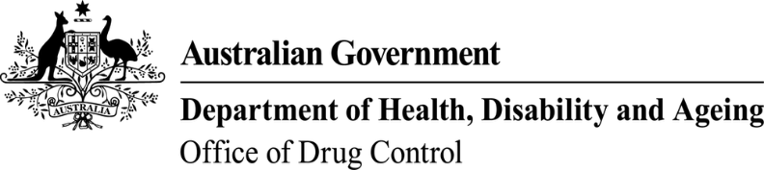 | This form, when completed, will be classified as  'For official use only'.

Application to add/remove authorised contact
Substances controlled under Regulation 5 of the Customs (Prohibited Imports) Regulations 1956 and Regulation 10 of the Customs (Prohibited Exports) Regulations 1958
- Licence details
Licence holder name: | Current import licence number:
Company name: | Current export licence number:

- Details of authorised contact to add/remove
 | Employee’s full name | Position held
Add ☐
Remove ☐
Add ☐
Remove ☐

A scanned copy of a National Police Certificate (NPC) must be included for all new authorised contacts. The NPC must be less than 12 months old.

- Declaration and consent
I declare that to the best of my knowledge all the information in this application is true, correct and complete. I am aware that giving false or misleading information is a serious offence—see Division 136 and 137 of the Criminal Code Act 1995.
I understand that it is standard practice for the Narcotics Control Section to provide any or all of the contents of this application, including personal information as defined in the Privacy Act 1988, to law enforcement agencies and regulatory agencies in the Commonwealth, States and Territories as necessary, in order to ensure laws and regulations are being complied with. I consent to all such disclosures and associated exchanges of information, including specifically personal information about me.
Signature of licence holder: | Date:
Signature of licence holder: | Position:
Signature of licence holder: | Email:
Name: | Telephone:

Schedule 1 - Personal details of proposed authorised contact
Please copy this page and complete for each proposed authorised contact as required

Proposed authorised contact’s full name: |  |  |  |  | Date of birth:
Company name: |  |  |  |  | Drivers licence number:
Previous names (if applicable):
Position held in company:
Contact phone number: |  |  |  |  | Contact email:
Current residential street address |  |  |  |  | Suburb/town |  |  | State | Postcode
Previous residential street addresses  (within last 5 years) |  |  |  |  | Suburb/town |  |  | State | Postcode
A scanned copy of a National Police Certificate (NPC) must be included for all new authorised contacts. The NPC must be less than 12 months old.

Declaration and consent
I declare that, to the best of my knowledge, all the information provided in this schedule is true, correct and complete. I am aware that giving false or misleading information is a serious offence—see Division 136 and 137 of the Criminal Code Act 1995.
I understand that it is standard practice for the Narcotics Control Section to provide any or all of the contents of this schedule, including personal information as defined in the Privacy Act 1988, to law enforcement agencies and regulatory agencies in the Commonwealth, States and Territories as necessary, in order to ensure laws and Regulations are being complied with.
I consent to all such disclosures and associated exchanges of information, including specifically personal information about me.
Signature of proposed authorised contact:

