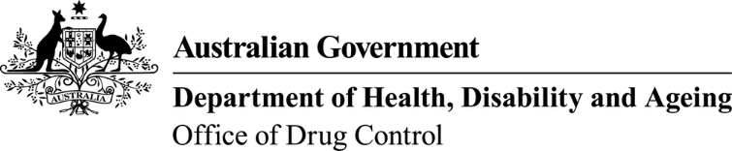
This form, when completed, will be classified as 'For official use only'.

Addition of proposed import/export activities (of controlled substances) to an import/export licence
Substances controlled under Regulation 5 of the Customs (Prohibited Imports) Regulations 1956 and Regulation 10 of the Customs (Prohibited Exports) Regulations 1958.
To assist in the completion of this form, guidance is available on the ODC website.
Licence holder or authorised person’s name: |  |  |  | Licence number:
Company name: |  |  |  | Company identification number:
A copy of state/territory Schedule 4, 8 or 9 licence is included (if not already provided): |  |  | Yes No |  | If already provided, date last provided:

Proposed import/export activities to be added to licence
Prohibited Import | Strength/ concentration of substance | Unit description | Number of units required annually | Import/ Export | (Office Use Only)
e.g. Morphine sulphate | 15mg/mL | 10mL vial | 50,000 | Export | Conversion factor | Base Drug Quantity | S/T Licence | NDS Drug Code
e.g. Oxycodone hydrochloride | Raw material | kilogram | 40 | Import/export

Signature of licence holder or authorised contact: | Name:
Signature of licence holder or authorised contact: | Date:

